© A M P A S ®

Technical Bulletin TB-2017-00x
ACES Output Transform User Guide

The Academy of Motion Picture Arts and Sciences Science and Technology Council
Academy Color Encoding System (ACES) Project Committee

August 18, 2017

Summary: The Academy Color Encoding System (ACES) includes a variety of Output Transforms intended to support a wide range of display devices. These devices include standard dynamic range digital cinema projectors, broadcast mon- itors, computer desktop displays, and high dynamic range displays. Each of these devices may be configured differently and requires an ACES output transforms be used based on the specifics of the configuration. This document is intended to be practical guide help end-users determine the proper ACES output transform to be used based on their devices, configurations, and workflows.

NOTICES
©2017 Academy of Motion Picture Arts and Sciences (A.M.P.A.S.). All rights reserved. This document is provided to individuals and organizations for their own internal use, and may be copied or reproduced in its entirety for such use. This document may not be published, distributed, publicly displayed, or transmitted, in whole or in part, without the express written permission of the Academy.
The accuracy, completeness, adequacy, availability or currency of this document is not warranted or guar- anteed. Use of information in this document is at your own risk. The Academy expressly disclaims all warranties, including the warranties of merchantability, fitness for a particular purpose and non-infringement.
Copies of this document may be obtained by contacting the Academy at councilinfo@oscars.org.
“Oscars,” “Academy Awards,” and the Oscar statuette are registered trademarks, and the Oscar statuette a copyrighted property, of the Academy of Motion Picture Arts and Sciences.
This document is distributed to interested parties for review and comment. A.M.P.A.S. reserves the right to change this document without notice, and readers are advised to check with the Council for the latest version of this document.
The technology described in this document may be the subject of intellectual property rights (including patent, copyright, trademark or similar such rights) of A.M.P.A.S. or others. A.M.P.A.S. declares that it will not enforce any applicable intellectual property rights owned or controlled by it (other than A.M.P.A.S. trademarks) against any person or entity using the intellectual property to comply with this document.
Attention is drawn to the possibility that some elements of the technology described in this document, or certain applications of the technology may be the subject of intellectual property rights other than those identified above. A.M.P.A.S. shall not be held responsible for identifying any or all such rights. Recipients of this document are invited to submit notification to A.M.P.A.S. of any such intellectual property of which they are aware.

These notices must be retained in any copies of any part of this document.

Revision History

Version | Date | Description
1.0 | 08/19/2017 | Initial Version

Related Academy Documents

Document Name | Description

Table of Contents

NOTICES 2
Revision History 3
Related Academy Documents 3
Introduction 7
- References 8
- Output Transform Applications 9
  - Theatrical Digital Intermediate (P3-DCI Calibrated Projector) 9
    - Summary 9
    - Projector Setup 9
    - Best ODT for application 9
    - Notes 9
    - Test Values 10
  - Theatrical Digital Intermediate (P3-D60 Calibrated Projector) 12
    - Summary 12
    - Projector Setup 12
    - Best ODT for application 12
    - Notes 12
    - Test Values 13
  - Theatrical On-Set Preview (Rec.709 SDR Reference Monitor) 15
    - Summary 15
    - Display Setup 15
    - Best ODT for application 15
    - Notes 15
    - Test Values 17
  - Theatrical On-Set Preview (iPad) 18
    - Summary 18
    - Best ODT for application 18
    - Notes 18
    - Test Values 18
  - Broadcast Television Mastering (Rec.709 SDR Reference Monitor) 19
    - Summary 19
    - Display Setup 19
    - Best ODT for application 19
    - Notes 19
    - Test Values 20
  - Broadcast Television On-Set Preview (Rec.709 SDR Reference Monitor) 22
    - Summary 22
    - Display Setup 22
    - Best ODT for application 22
    - Notes 22
    - Test Values 23
  - Broadcast Television On-Set Preview (iPad) 25
    - Summary 25
    - Best ODT for application 25
    - Notes 25
    - Test Values 25
  - High Dynamic Range On-Set Preview (Rec.2020 HDR Reference Monitor) 26
    - Summary 26
    - Best ODT for application 26
    - Notes 26
    - Test Values 26
  - Computer Visual Effects (VFX) Generation (Desktop Computer Monitor) 27
    - Summary 27
    - Best ODT for application 27
    - Notes 27
    - Test Values 27
  - HDR10 Deliverable Generation (HDR 1000 nit Rec.2020 ST-2084) 28
    - Summary 28
    - Best ODT for application 28
    - Notes 28
    - Test Values 28
  - Dolby Vision Master (4000 nit Dolby Pulsar PQ Master) 29
    - Summary 29
    - Best ODT for application 29
    - Notes 29
    - Test Values 29
- Recommended Workflows 30
  - Feature Film – On-Set to Digital Intermediate 30
    - Summary 30
    - Workflow 30
    - Discussion 30

Introduction
ACES 1.0 includes thirteen Output Transforms that can be broadly characterized as applying to four different display types used in various configurations. (Table 1) The display types include digital cinema projectors typically used in digital intermediate, motion picture mastering, and theatrical exhibition, standard dynamic range (SDR) broadcast displays used in editorial and on-set preview applications, high dynamic range (HDR) broadcast displays used in mastering an exhibition of HDR content, and computer desktop monitors such as those typically used in the creation of computer generated visual effects (VFX).

Output Transform (Short Name) Display Type

ACES 1.0 Output - P3-DCI | Digital Cinema Projector (SDR)
ACES 1.0 Output - P3-D60 | Digital Cinema Projector (SDR)
ACES 1.0 Output - DCDM | Digital Cinema Projector (SDR)
ACES 1.0 Output - DCDM (P3 gamut clip) | Digital Cinema Projector (SDR)
ACES 1.0 Output - Rec.709 | SDR Broadcast Monitor
ACES 1.0 Output - Rec.709 (D60 sim.) | SDR Broadcast Monitor
ACES 1.0 Output - Rec.2020 | SDR Broadcast Monitor
ACES 1.0 Output - P3-D60 ST2084 (1000 nits) | HDR Broadcast Monitor
ACES 1.0 Output - P3-D60 ST2084 (2000 nits) | HDR Broadcast Monitor
ACES 1.0 Output - P3-D60 ST2084 (4000 nits) | HDR Broadcast Monitor
ACES 1.0 Output - Rec.2020 ST2084 (1000 nits) | HDR Broadcast Monitor
ACES 1.0 Output - sRGB | Desktop Computer Display
ACES 1.0 Output - sRGB (D60 sim.) | Desktop Computer Display
Table 1 – ACES 1.0 Output Transforms and Display Types

The output device to be used with any particular device depends on the detailed configuration of that device. This document is intended to be practical guide help end-users determine the proper ACES output transform to be used the configuration, workflow, and intended usage. This document is intended to cover a series of common use cases. There may be valid uses of the ACES output transforms that fall outside of the scope of this document.

References
The following standards, specifications, articles, presentations, and texts are referenced in this text: SMPTE ST 2065-1:2012, Academy Color Encoding Specification (ACES)
SMPTE ST 2084:2014, Dynamic Range Electro-Optical Transfer Function of Mastering Reference Displays
ITU-R Rec. BT.1886, Reference electro-optical transfer function for flat panel displays used in HDTV studio production
ITU-R Rec. BT.2020, Parameter values for ultra-high definition television systems for production and inter- national programme exchange
ITU-R Rec. BT.2100, Image parameter values for high dynamic range television for use in production and international programme exchange

Output Transform Applications

Theatrical Digital Intermediate (P3-DCI Calibrated Projector)

Summary
It is common in the digital intermediate process (DI) to color correct motion pictures and episodic television shows while displaying the images using a DCI compliant digital cinema projector. DCI compliant digital cinema projectors have a simplified setup using a projector configuration file (PCF) that contains all the relevant projector settings and can often be loaded at the press of a button. The most common PCF used in motion picture and television production is the “DCI-P3” PCF. Using this PCF, the projector will be configured such that equal red, green, and blue projector code values will produce the chromaticity x=0.3140 y=0.3510 on the screen. With the projector configured in this manner it is recommended that the ACES 1.0 ODT with the transformID ODT.Academy.P3DCI 48nits.a1.0.3 be used.

Projector Setup

Parameter | Setting
PCF | DCI-P3 (RGB 4:4:4 Full Range, P3 Primaries, DCI white point, 48 nit max Luminance)
Viewing Environment | Dark
Bit Depth | 12-bit
Table 2 – P3-DCI Projector Setup

Best ODT for application

Simple Name | TransformID
ACES 1.0 Output - P3-DCI | ODT.Academy.P3DCI 48nits.a1.0.3
Table 3 – P3-DCI Best ODT

Notes
Using the “DCI-P3” PCF, the projector will be configured such that equal red, green, and blue display code values will produce the chromaticity x=0.3140 y=0.3510 on the screen. However, the ODT.Academy.P3 DCI 48nits.a1.0.3 transform is configured such that neutral ACES source file values (ACES R=G=B) will produce non-equal projector code values. The chromaticity of produced on screen by those non-equal projector code values will be x=0.32168 y=0.33767 (aka D60).
It’s important to note that the image on projection screen may look distinctly less green then some workflows that utilize a projector setup with the “DCI-P3” PCF. This will also be reflected on the color corrector scopes when neutral ACES values sent through the ODT.Academy.P3DCI 48nits.a1.0.3 transform. (Figure 1a, 1b, 1c, 1d, 1e) For instance, neutral ACES values processed through ODT.Academy.P3DCI 48nits. a1.0.3 will not have equal levels on the waveform, nor will they land in the middle of the vector scope. This behavior was intentional. The image may also have a distinctly magenta cast on a computer monitor such as the one used for the color corrector user interface if that monitor is calibrated to a D65 white point. (Figure 1f) Although not noted in the name of this ODT, the mimics the behavior found in other ODTs included in ACES 1.0 and labeled “D60 sim”. Due to this “D60 sim” behavior the maximum output screen luminance of neutral ACES values will be slightly less than the maximum luminance produced by projector code values red = 1, green = 1, blue = 1 (e.g. 48 nits).

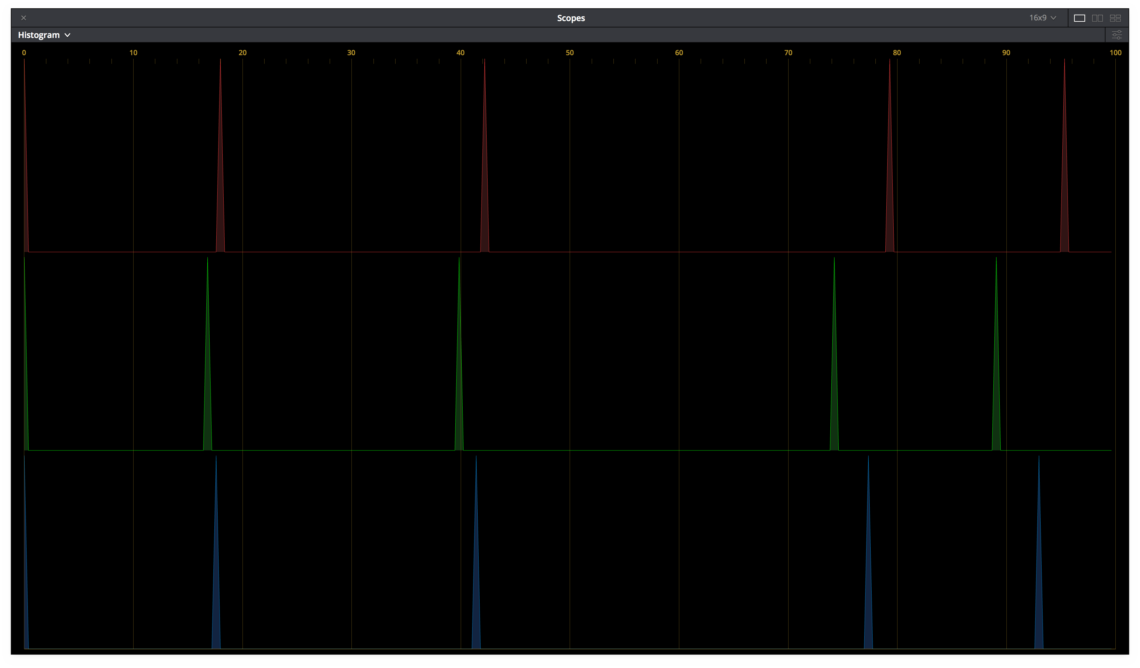
When using the correct projector setup and corresponding ODT, the image on the projector screen will match nearly exactly in Application 2.1 and Application 2.2.
      - ACES Image (b) Histogram
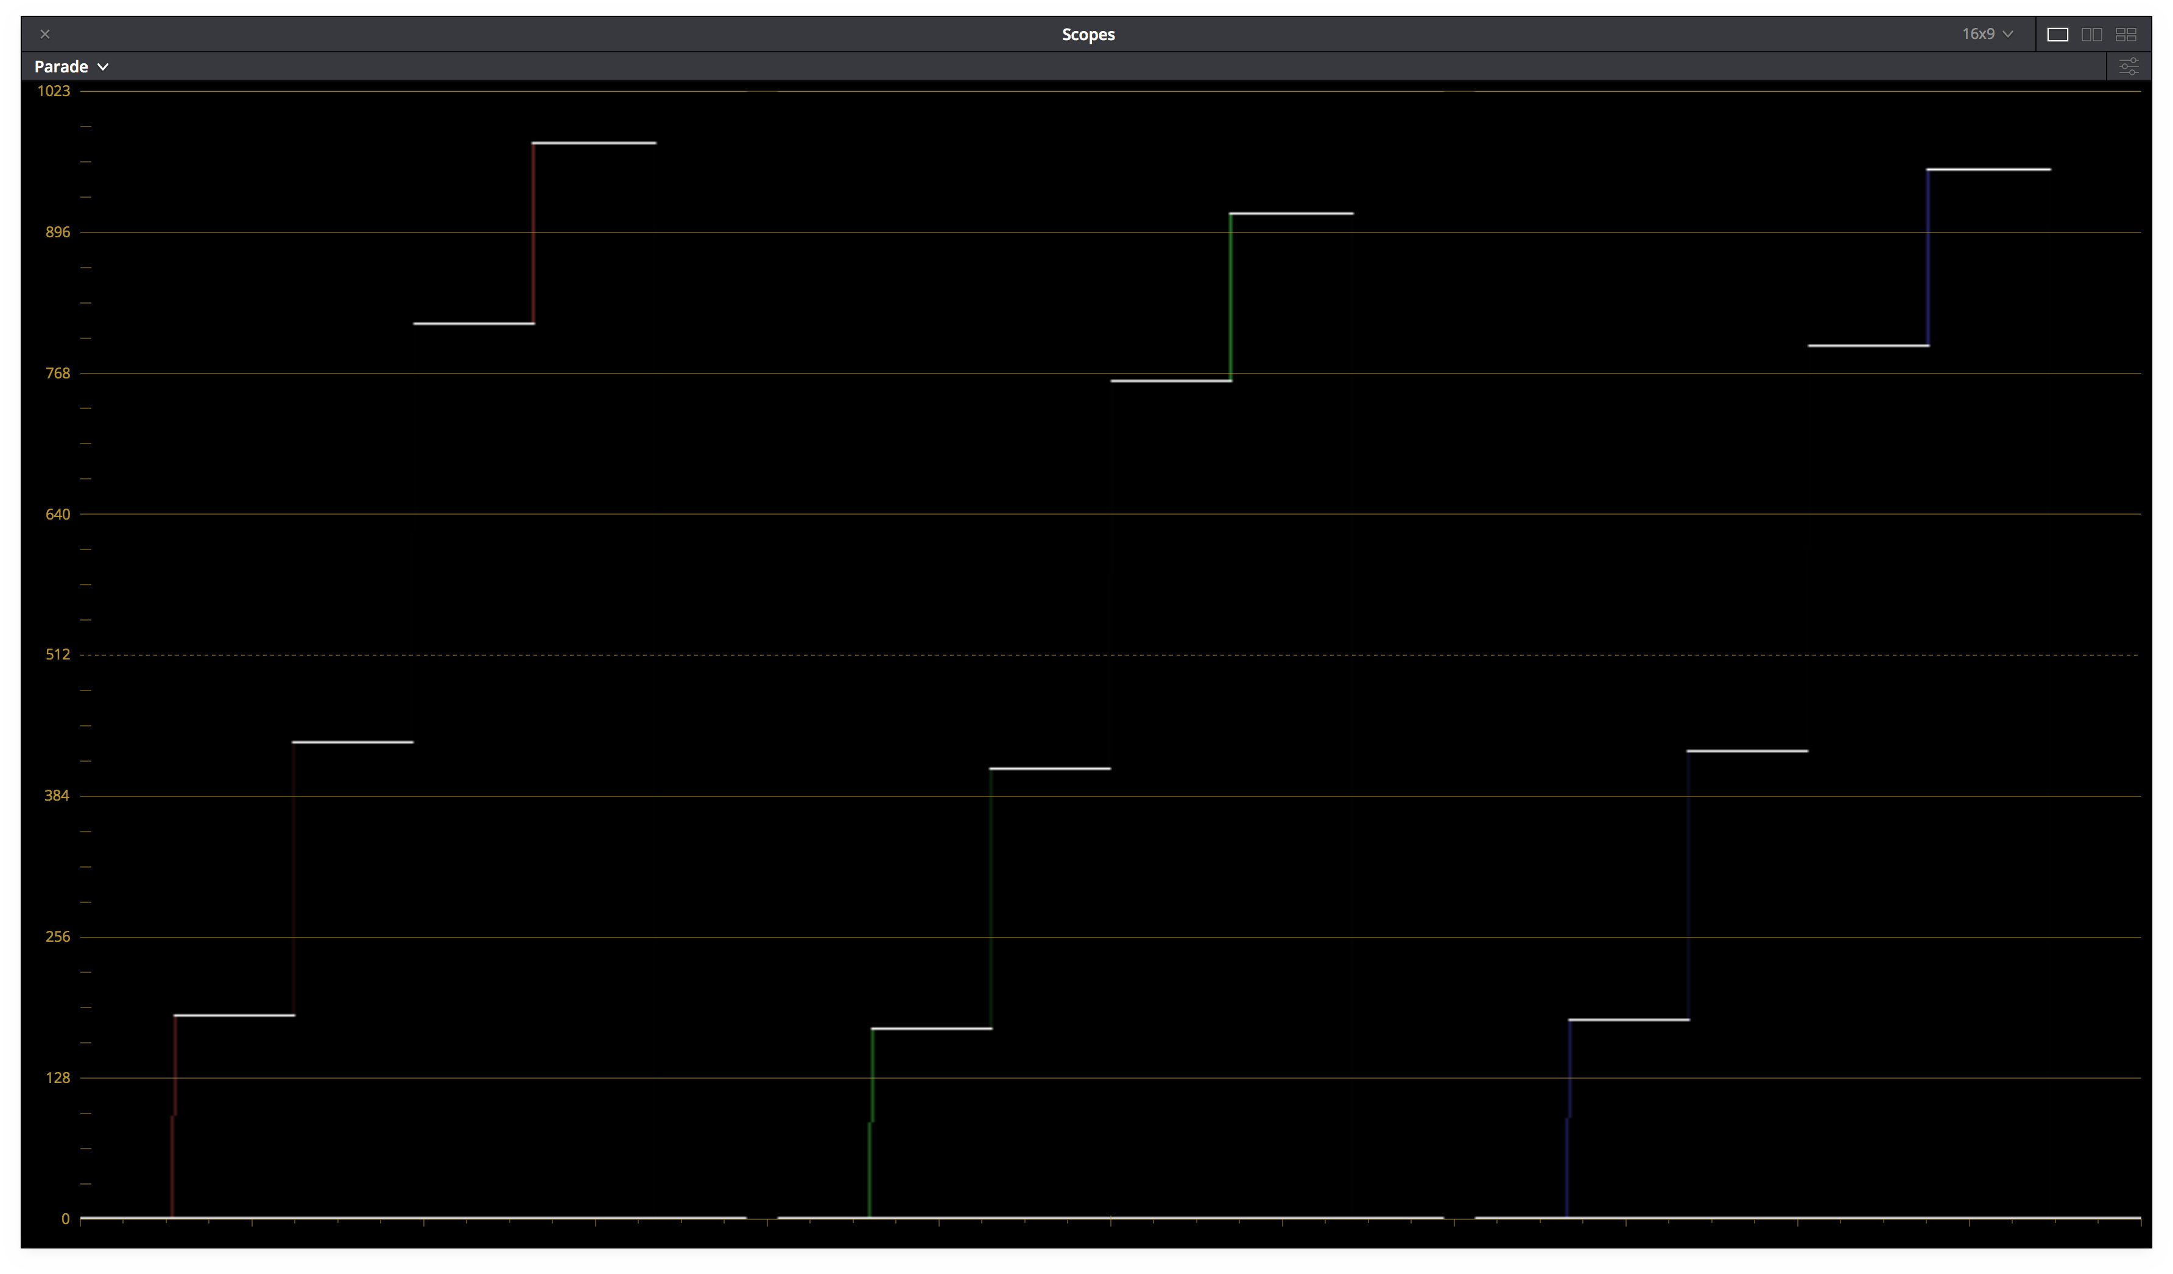
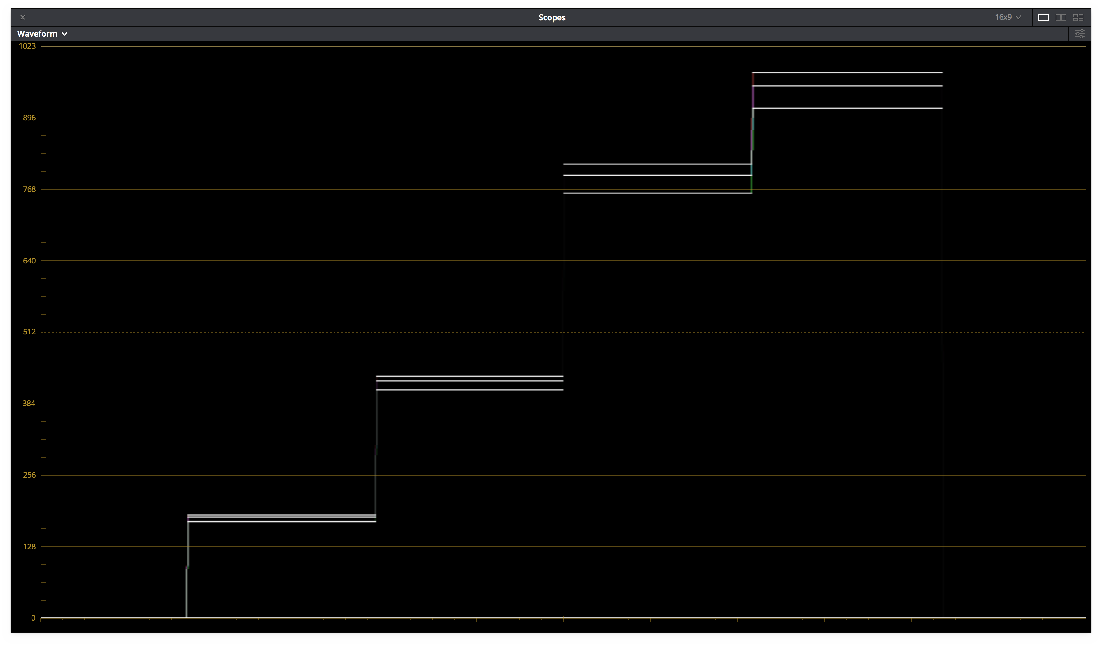
(c) Parade (d) Waveform

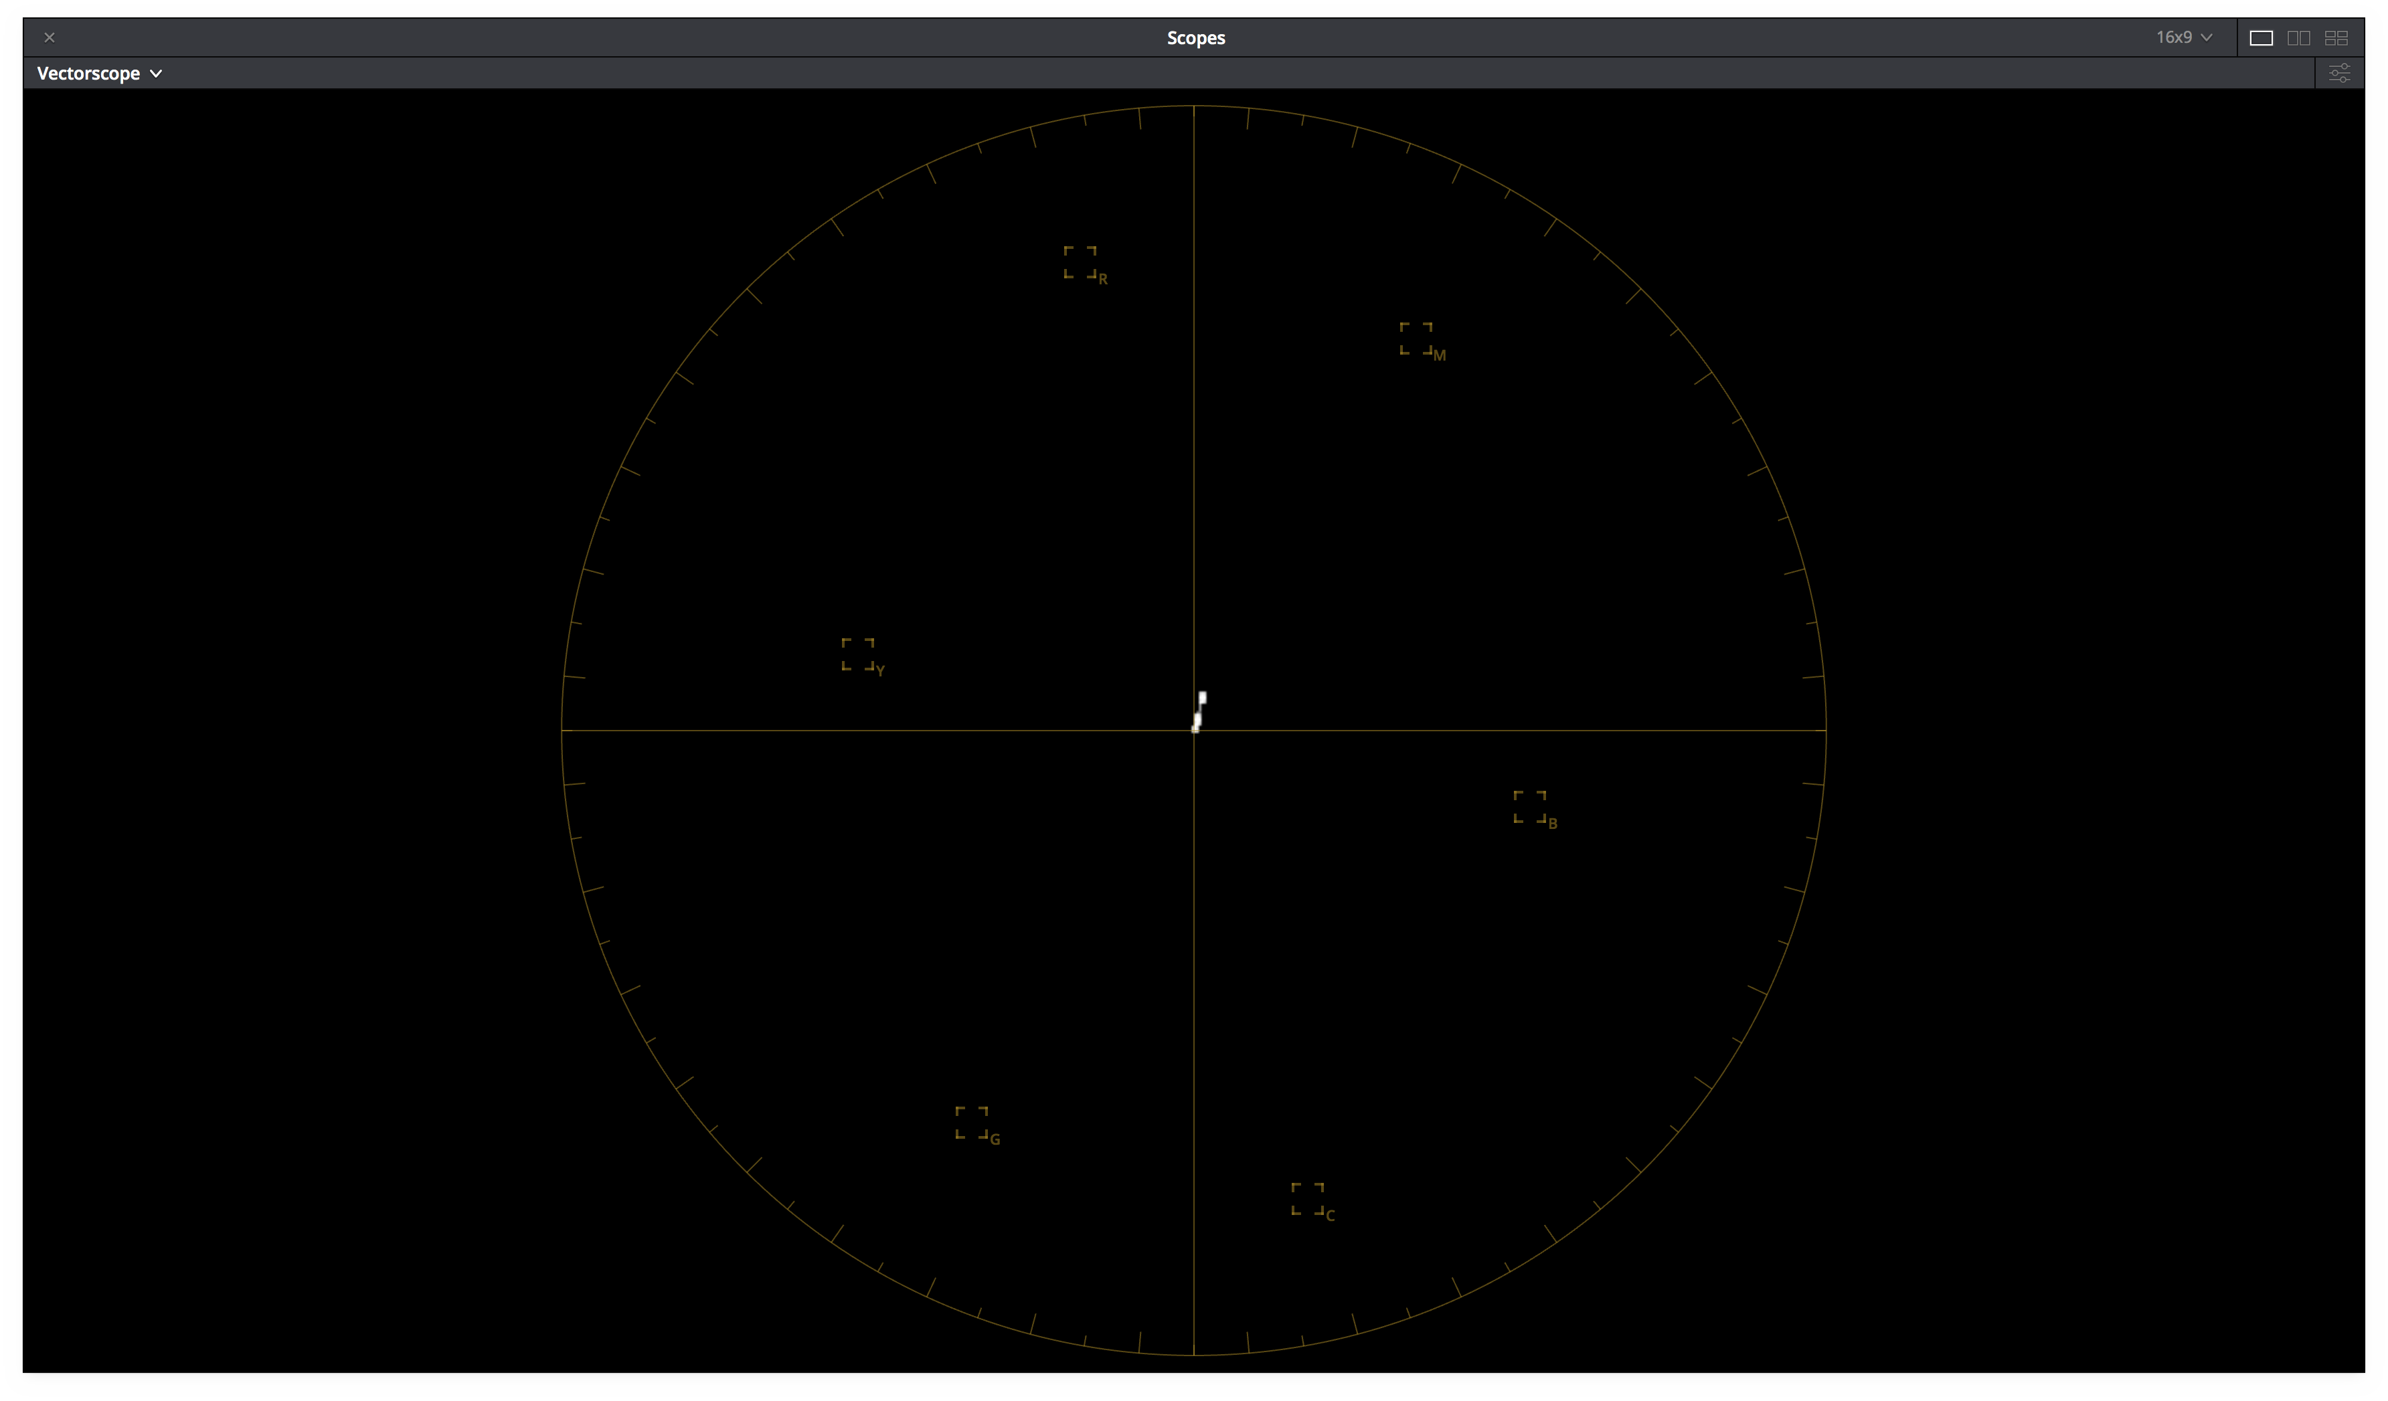
        - vectorscope
        - Projector code values as displayed on a D65 cali- brated computer monitor

Figure 1 – ODT.Academy.P3DCI 48nits.a1.0.3 Scope Screenshots

Test Values
Table 4 contains test values can be used to confirm the proper monitor setup and ODT combination. Each of the 9 ACES RGB input values should yield the RGB noted display RGB code values (normalized 0-1, full range) when processed through the ODT.Academy.P3DCI 48nits.a1.0.3. When driving a properly setup display with the noted display RGB code values, the light from the display should measure with the noted CIE xyY colorimetry.
If the display RGB code values do not match those in the table when using the corresponding input ACES RGB code values, it is likely the wrong ODT is being used. If the proper display RGB code values are being produced by the ODT, but he measured display colorimetry doesn’t match the display xyY code values noted, it is likely the display setup is incorrect.

Patch | ACES RGB |  |  | Display RGB |  |  | Display xyY
N1 | 1.8233 | 1.8233 | 1.8233 | 0.9243 | 0.8651 | 0.9013 | 0.3217 | 0.3377 | 34.4858
N2 | 0.2753 | 0.2753 | 0.2753 | 0.5383 | 0.5038 | 0.5249 | 0.3217 | 0.3377 | 8.4552
N3 | 0.0898 | 0.0898 | 0.0898 | 0.2804 | 0.2625 | 0.2734 | 0.3217 | 0.3377 | 1.5514
R | 0.4689 | 0.1193 | 0.0417 | 0.8046 | 0.2227 | 0.1795 | 0.6413 | 0.3307 | 6.4488
G | 0.339 | 0.8068 | 0.0936 | 0.4335 | 0.8036 | 0.2434 | 0.3046 | 0.624 | 20.8422
B | 0.2162 | 0.133 | 0.8711 | 0.1707 | 0.1503 | 0.8215 | 0.1562 | 0.0692 | 2.3365
C | 0.5187 | 0.9138 | 1.0432 | 0.4332 | 0.8028 | 0.8406 | 0.2269 | 0.3404 | 22.8164
M | 0.58 | 0.2096 | 0.9086 | 0.808 | 0.2134 | 0.8294 | 0.333 | 0.1596 | 8.4349
Y | 0.8237 | 0.9378 | 0.0855 | 0.8654 | 0.8096 | 0.2487 | 0.4338 | 0.5187 | 26.9923

Table 4 – ODT.Academy.P3DCI 48nits.a1.0.3 Test Values

Theatrical Digital Intermediate (P3-D60 Calibrated Projector)

Summary
It is common in the digital intermediate process (DI) to color correct motion pictures and episodic television shows while displaying the images using a DCI compliant digital cinema projector. DCI compliant digital cinema projectors have a simplified setup using a projector configuration file (PCF) that contains all the relevant projector settings and can often be loaded at the press of a button. The recommended PCF to be used with digital cinema projectors and ACES-based workflows is the “P3-D60” PCF (add link). Using this PCF, the projector will be configured such that equal red, green, and blue projector code values will produce the chromaticity x=0.32168 y=0.33767 (aka D60). With the projector configured in this manner it is recommended that ACES ODT with the transformID ODT.Academy.P3D60 48nits.a1.0.3 be used.

Projector Setup

Parameter | Setting
PCF | P3D60(RGB 4:4:4 Full Range, P3 Primaries, D60 white point, 48 nit max Luminance)
Viewing Environment | Dark
Bit Depth | 12-bit
Table 5 – P3-DCI Projector Setup

Best ODT for application

Simple Name | TransformID
ACES 1.0 Output - P3-D60 | ODT.Academy.P3D60 48nits.a1.0.3
Table 6 – P3-DCI Best ODT

Notes
The “P3-D60” PCF is not typically included by the manufacturer by default in most digital cinema projectors. It must be downloaded and installed in the projector using the appropriate projector configuration software (e.g. DCP Librarian). Once the PCF is installed and activated neutral ACES values sent through the the OD T.Academy.P3D60 48nits.a1.0.3 transform will produce equal red, green and blue projector code values, will have equal levels on the waveform, will land in the middle of the vector scope, will appear neutral on a D65 calibrated computer monitor, and will produce the chromaticity x=0.32168 y=0.33767 (aka D60) on the projection screen. (Figure 2a, 2b, 2c, 2d, 2e)
Often the resulting projector code values are saved into a file and converted using specialized tools (e.g. Clipster) into DCDMs and/or a DPC for distribution. It is important to note that many conversion tools assume that equal red, green, and blue projector code values are intended to produce a chromaticity of x=0.3140 y=0.3510 on the screen. Converting the projector code values from ODT.Academy.P3D60 48nits.a1
  - using such tools will result in incorrect DCDM and/or DCP files. The tools must explicitly be capable of converting projector code values where equal red, green, and blue projector code values are intended to produce a chromaticity x=0.32168 y=0.33767 (aka D60) on the screen.
When using the correct projector setup and corresponding ODT, the image on the projector screen will match nearly exactly in Application 2.1 and Application 2.2.

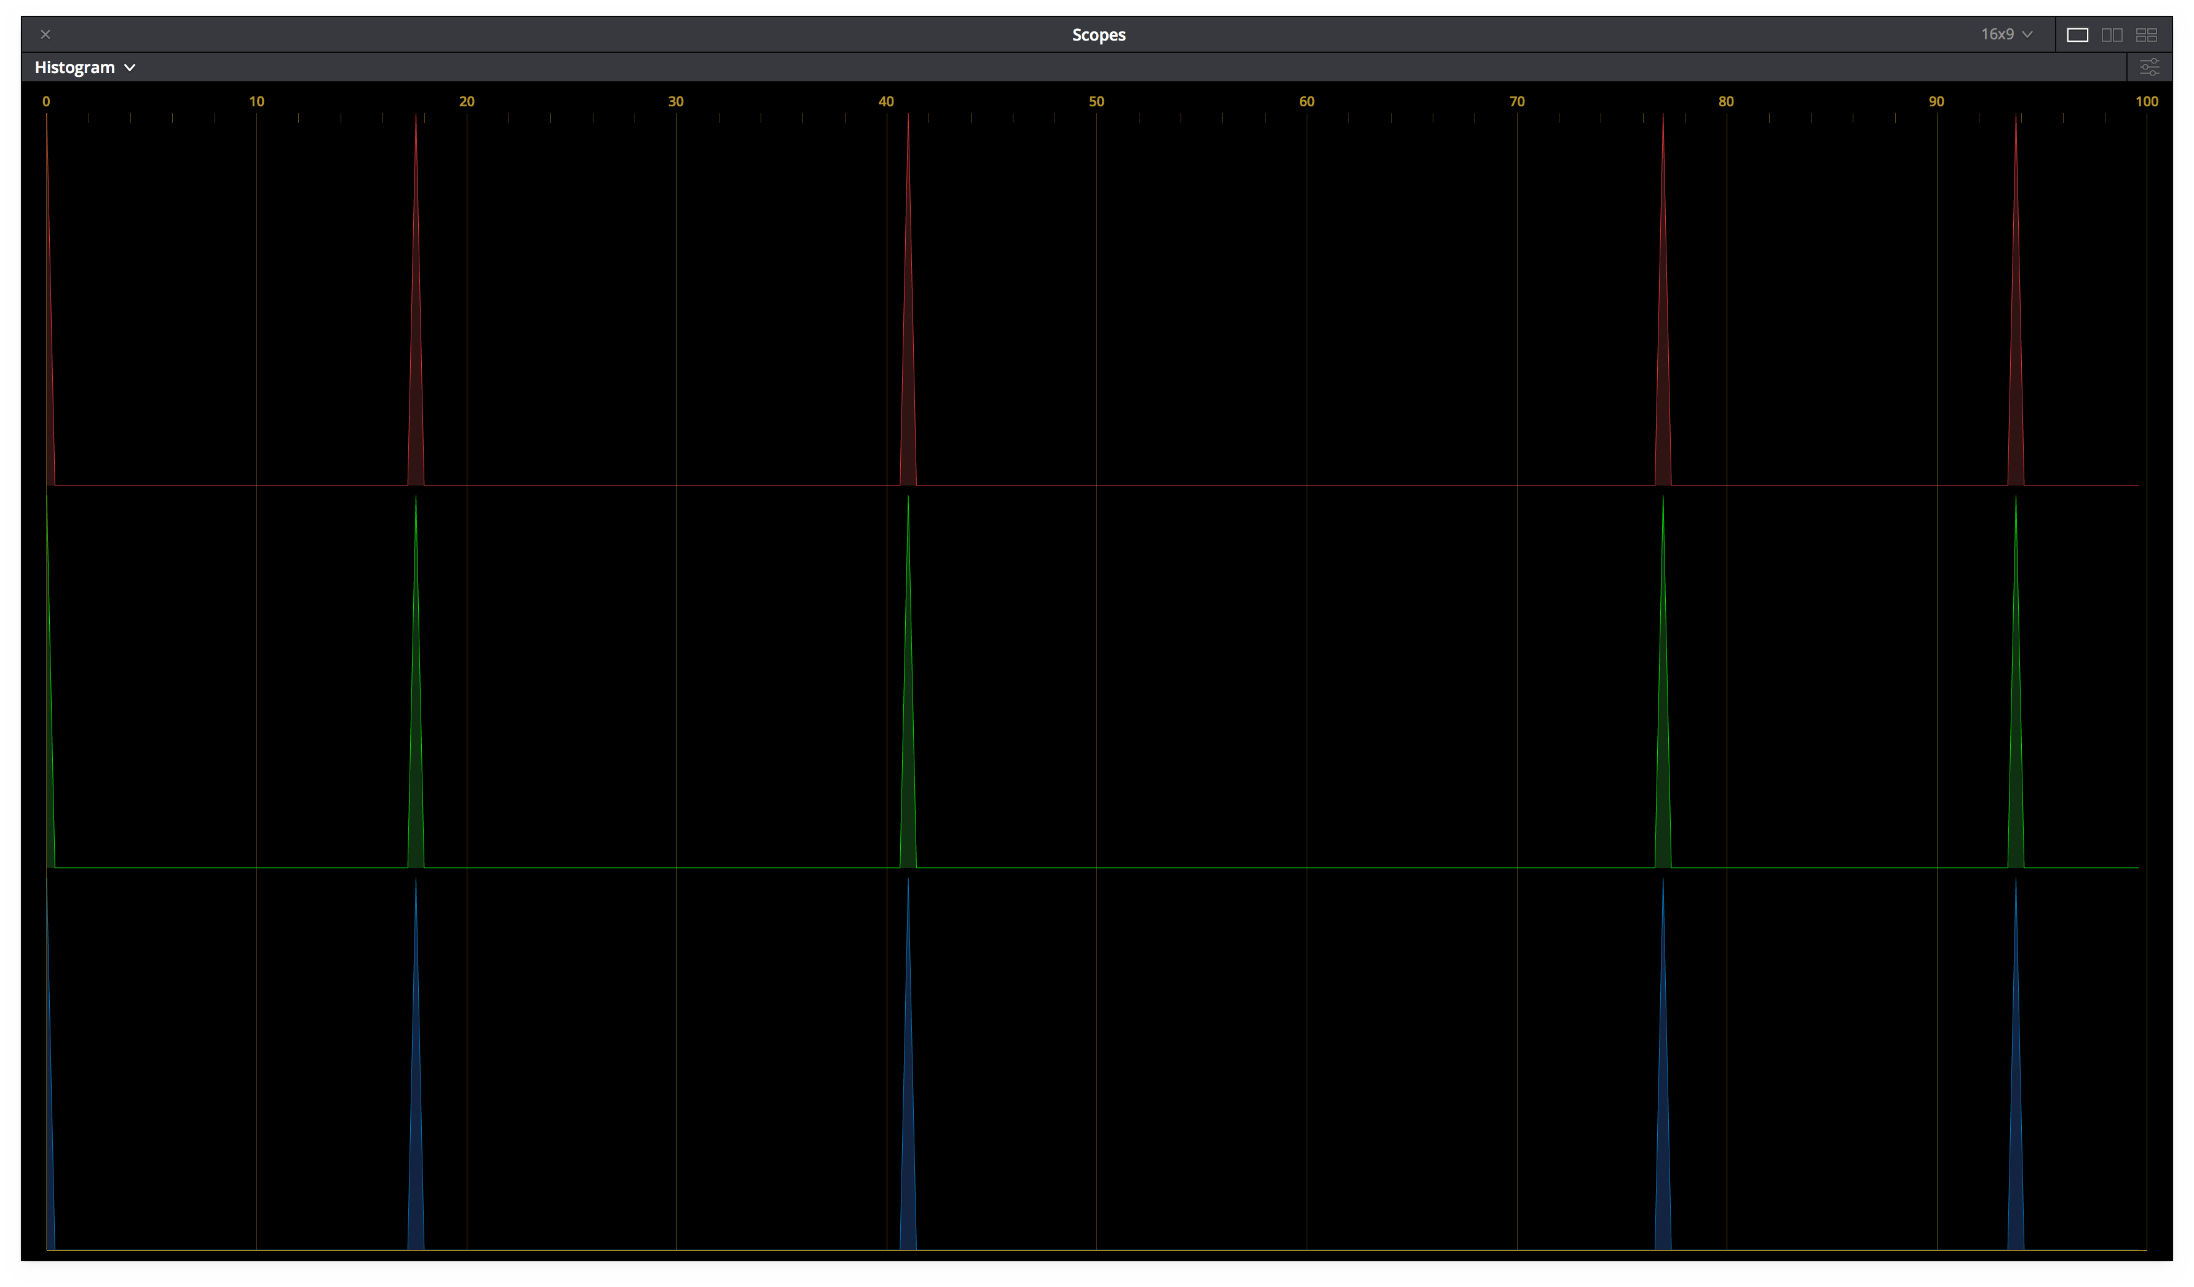
    - ACES Image (b) Histogram
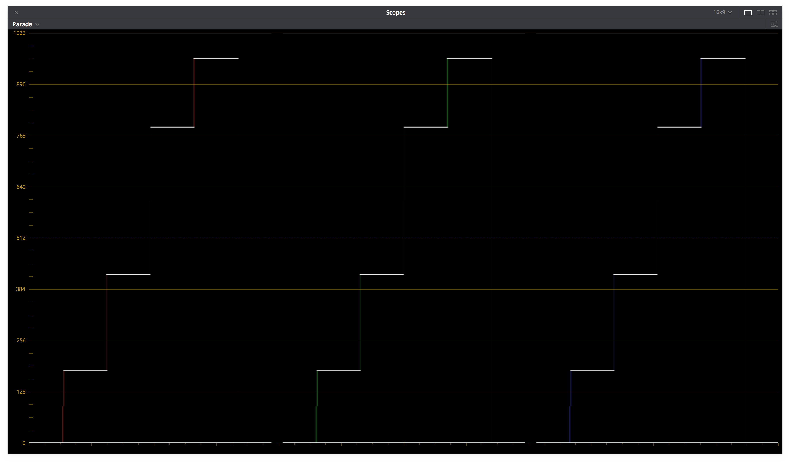
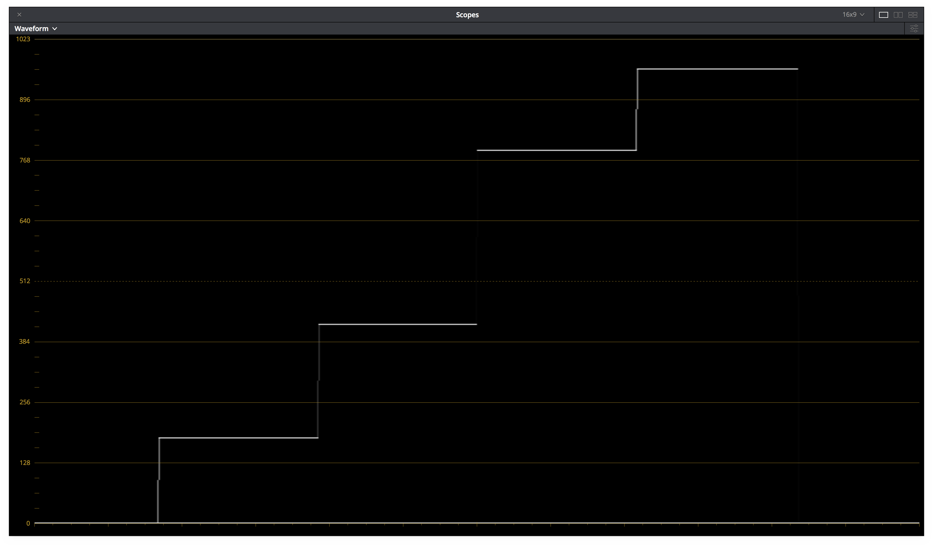
(c) Parade (d) Waveform

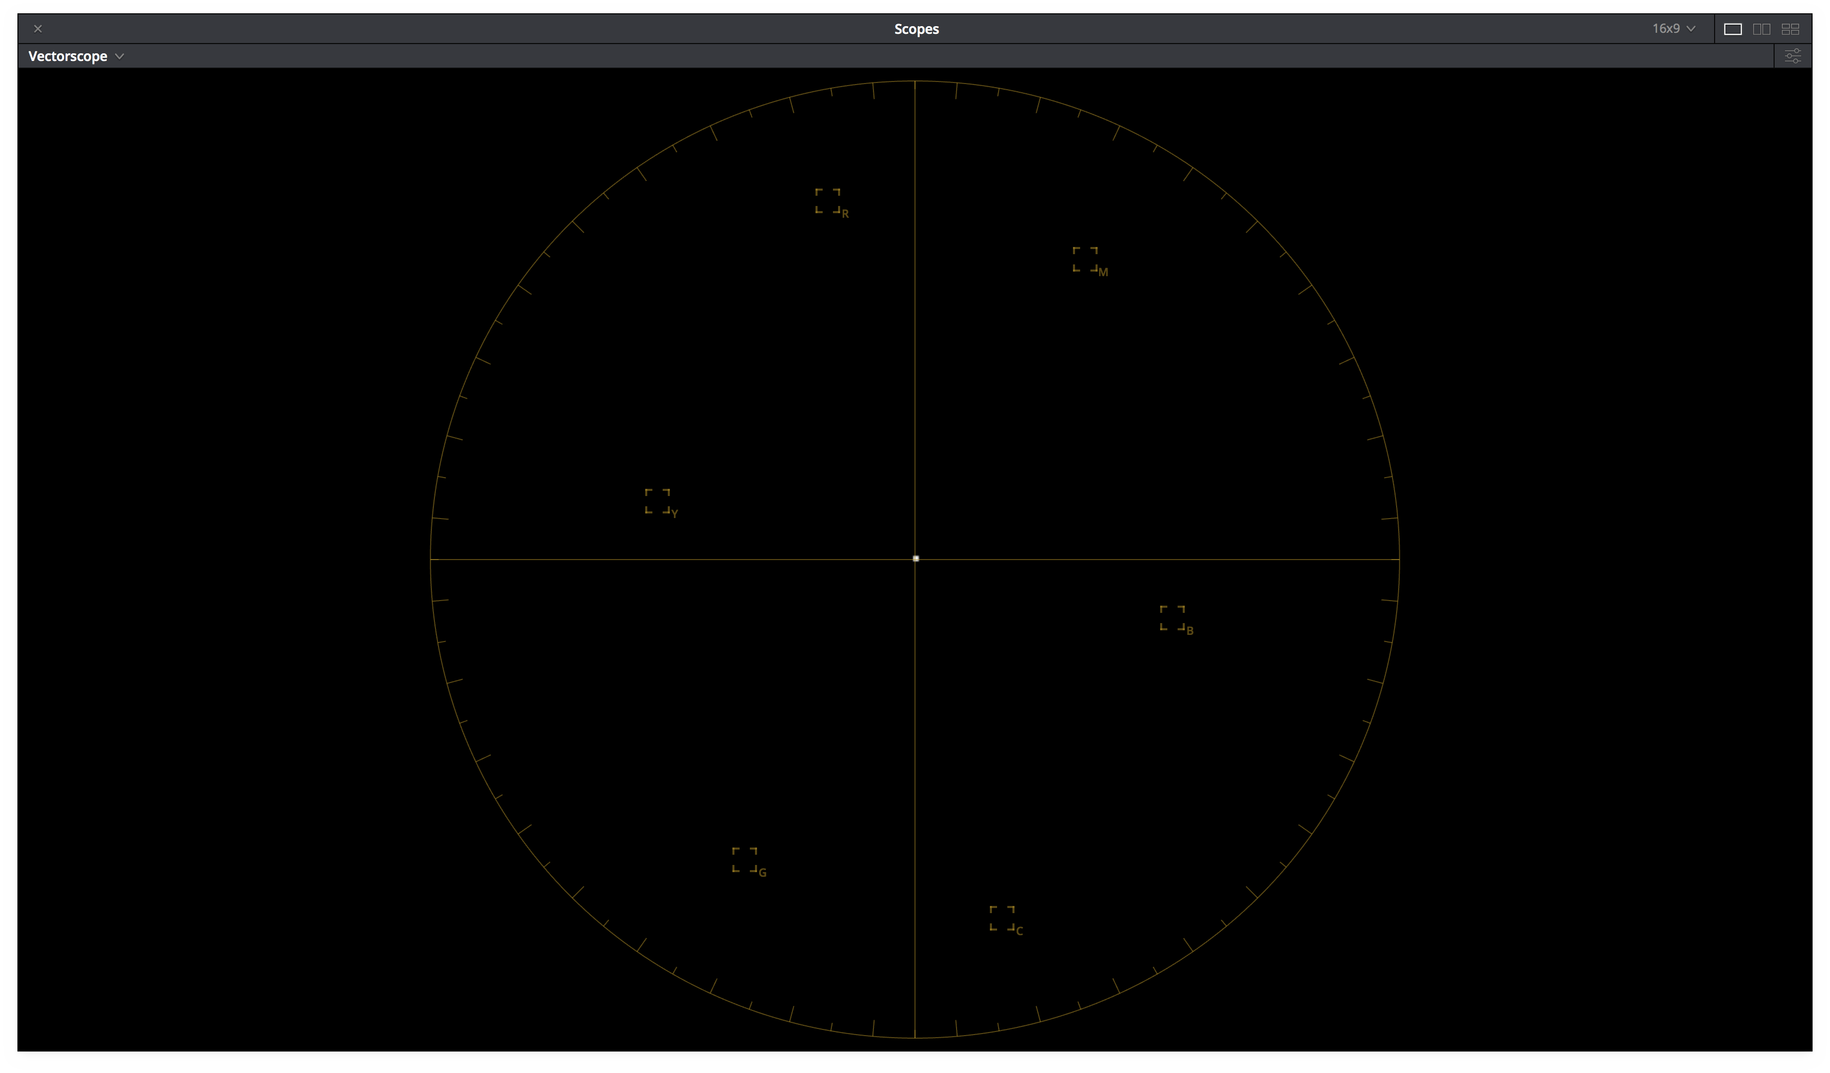
      - vectorscope
      - Projector code values as displayed on a D65 cali- brated computer monitor

Figure 2 – ODT.Academy.P3D60 48nits.a1.0.3 Scope Screenshots

2.2.5 Test Values
Table 7 contains test values can be used to confirm the proper monitor setup and ODT combination. Each of the 9 ACES RGB input values should yield the RGB noted display RGB code values (normalized 0-1, full range) when processed through the ODT.Academy.P3D60 48nits.a1.0.3. When driving a properly setup display with the noted display RGB code values, the light from the display should measure with the noted CIE xyY colorimetry.
If the display RGB code values do not match those in the table when using the corresponding input ACES RGB code values, it is likely the wrong ODT is being used. If the proper display RGB code values are being produced by the ODT, but he measured display colorimetry doesn’t match the display xyY code values noted, it is likely the display setup is incorrect.

Patch | ACES RGB |  |  | Display RGB |  |  | Display xyY
N1 | 1.8233 | 1.8233 | 1.8233 | 0.9056 | 0.9056 | 0.9056 | 0.3217 | 0.3377 | 37.0944
N2 | 0.2753 | 0.2753 | 0.2753 | 0.5209 | 0.5209 | 0.5209 | 0.3217 | 0.3377 | 8.8075
N3 | 0.0898 | 0.0898 | 0.0898 | 0.2714 | 0.2714 | 0.2714 | 0.3217 | 0.3377 | 1.6161
R | 0.4689 | 0.1193 | 0.0417 | 0.7786 | 0.2302 | 0.1781 | 0.6413 | 0.3307 | 6.7175
G | 0.339 | 0.8068 | 0.0936 | 0.4184 | 0.8322 | 0.2411 | 0.3042 | 0.6246 | 21.7918
B | 0.2162 | 0.133 | 0.8711 | 0.1647 | 0.1553 | 0.816 | 0.1562 | 0.0692 | 2.4372
C | 0.5187 | 0.9138 | 1.0432 | 0.4174 | 0.8317 | 0.8371 | 0.2263 | 0.3398 | 23.8751
M | 0.58 | 0.2096 | 0.9086 | 0.7819 | 0.2206 | 0.8243 | 0.3325 | 0.1593 | 8.7918
Y | 0.8237 | 0.9378 | 0.0855 | 0.8392 | 0.8399 | 0.2459 | 0.4336 | 0.5192 | 28.3358

Table 7 – ODT.Academy.P3D60 48nits.a1.0.3 Test Values

Theatrical On-Set Preview (Rec.709 SDR Reference Monitor)

Summary
In theatrical workflows it is often desirable to preview the final look of the image on set as it is expected to appear during final color grading and mastering. Using ACES based workflows it is likely the default chromaticity of neutrals will be x=0.32168 y=0.33767 (aka D60) on the DI projection screen regardless of the projector’s calibration white point. In order to properly preview this on-set it is recommended a Rec.709 SDR reference monitor with a calibration white point of CIE x=0.3127 y=0.3290 (aka D65) be used in conjunction with the ACES Output Transform ODT.Academy.Rec709 D60sim 100nits dim.a1.0
.3.

Display Setup

Parameter | Setting
Max Luminance | 100 nits
Display White Point | D65
Primaries | Rec.709
EOTF | BT.1886
Viewing Environment | dim
Signal | RGB 4:4:4 (Full range or Legal Range)
Bit Depth | 10 or 12-bit
Table 8 – Rec.709 Display Setup

Best ODT for application

Simple Name | TransformID
ACES 1.0 Output - Rec.709 (D60 sim.) | ODT.Academy.Rec709 D60sim 100nits dim.a1.0.3
Table 9 – Best Theatrical On-Set Preview ODT

Notes
Using a Rec.709 SDR reference monitor with a calibration white point of D65 in in conjunction with the ACES Output Transform ODT.Academy.Rec709 D60sim 100nits dim.a1.0.3 will cause
Using a Rec.709 SDR reference monitor with a calibration white point of D65 will cause equal red, green, and blue display code values to produce the chromaticity x=0.3127 y=0.3290 on the display screen. However, the ODT.Academy.Rec709 D60sim 100nits dim.a1.0.3 transform is configured such that neutral ACES source file values (ACES R=G=B) will produce non-equal display code values. The chromaticity of produced on screen by those non-equal projector code values will be x=0.32168 y=0.33767 (aka D60). This is intentional and designed such that the image appearance on the on-set Rec.709 SDR reference monitor will mimic that of the final image displayed in DI mastering.
It’s important to note that the image on projection screen may look less blue then some video based workflows. This will also be reflected on the color corrector scopes when neutral ACES values sent through the ODT.A cademy.Rec709 D60sim 100nits dim.a1.0.3 transform. (Figure 3a, 3b, 3c, 3d, 3e) For instance, neutral ACES values processed through ODT.Academy.Rec709 D60sim 100nits dim.a1.0.3 will not have equal levels on the waveform, nor will they land in the middle of the vector scope. This behavior was intentional. The image may also have a slightly warm cast on a computer monitor such as the one used

for the color corrector user interface if that monitor is calibrated to a D65 white point when compared to images generated using some traditional video workflows. (Figure 1f) In the ACES system, the behavior of mimicking the default DI look in the on-set environment is known as “D60 sim”. Due to this “D60 sim” behavior the maximum output screen luminance of neutral ACES values will be slightly less than the maximum luminance produced by display code values red = 1, green = 1, blue = 1 (e.g. 100 nits).
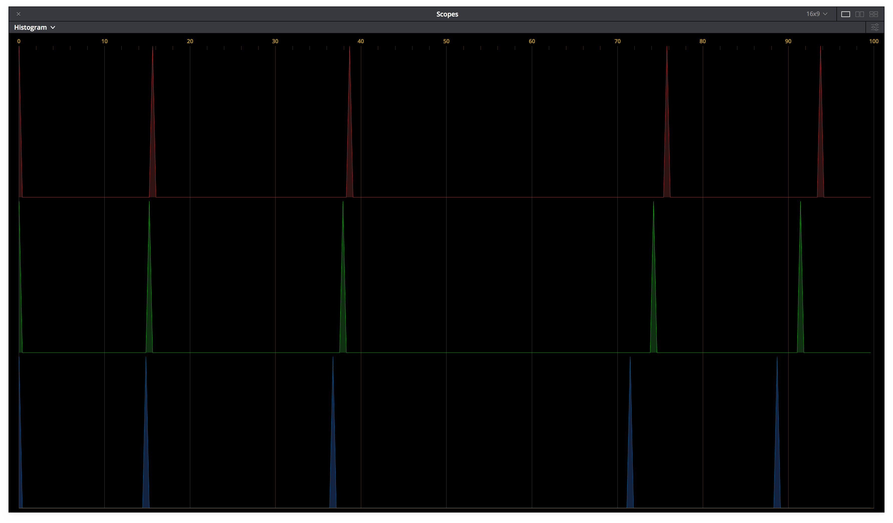
When using the correct Rec.709 reference display setup and corresponding ODT, the image on the projector screen will have a similar appearance to that of Application 2.1 and Application 2.2. However, the images will not measure exactly the same due the fact the Rec.709 reference display’s max luminance is 100 nits vs 48 nits in DI, and the ODT.Academy.Rec709 D60sim 100nits dim.a1.0.3 compensates for a dim viewing environment.
      - ACES Image (b) Histogram
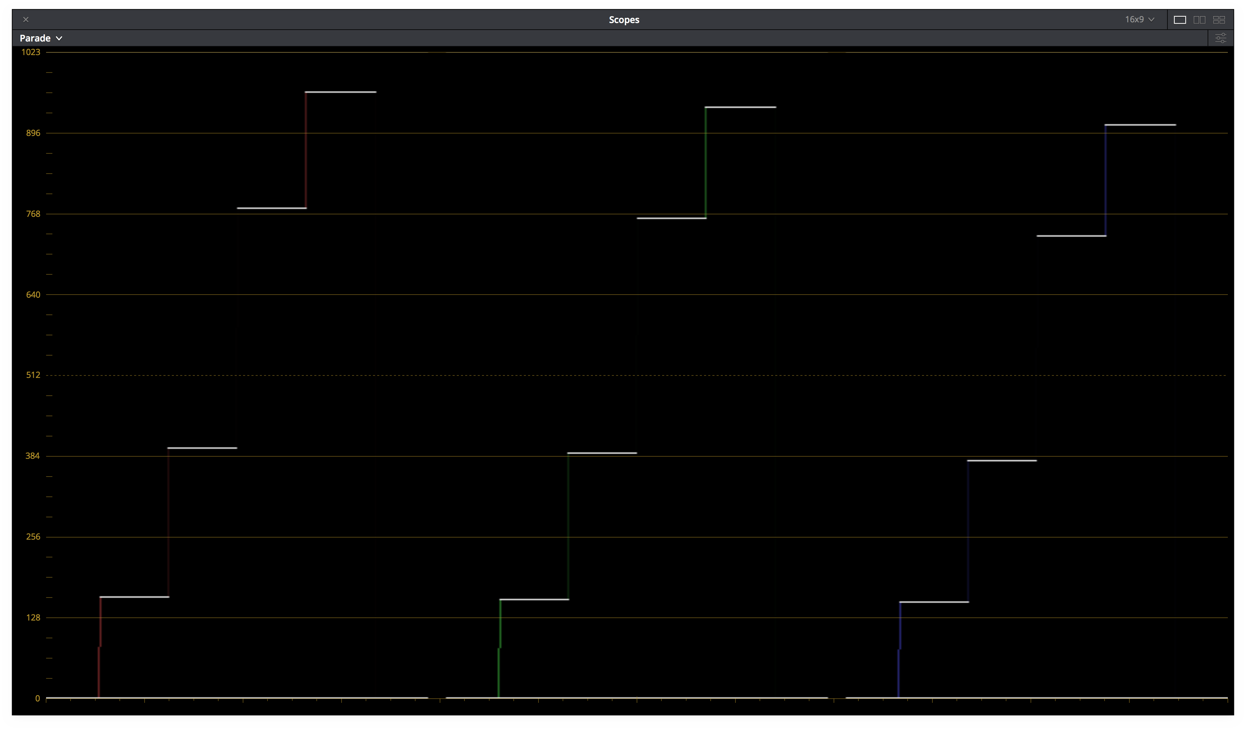
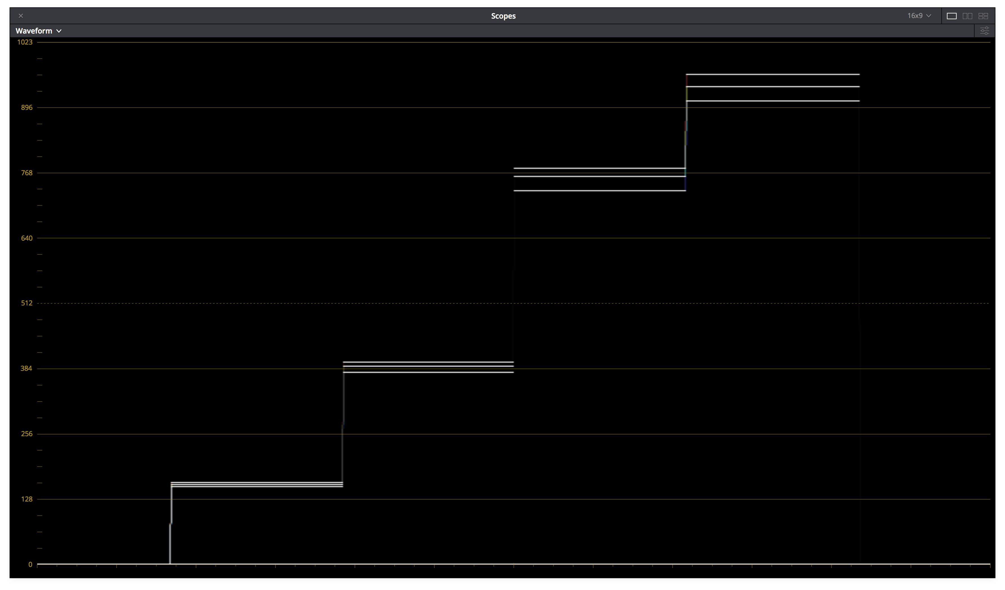
(c) Parade (d) Waveform

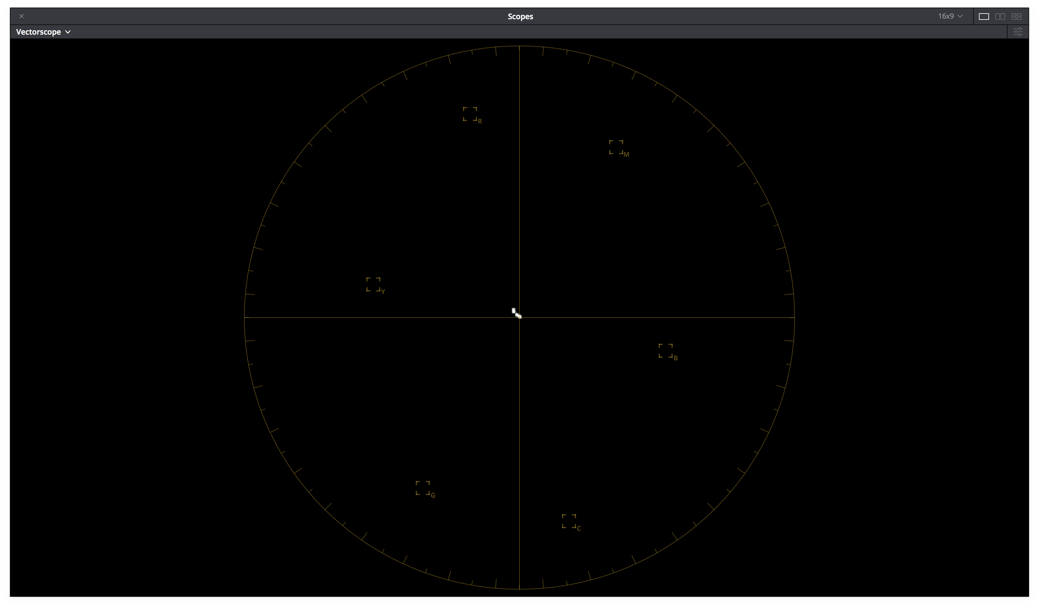
        - vectorscope
        - Projector code values as displayed on a D65 cali- brated computer monitor

Figure 3 – ODT.Academy.Rec709 100nits dim.a1.0.3 Scope Screenshots

Test Values
Table 9 contains test values can be used to confirm the proper monitor setup and ODT combination. Each of the 9 ACES RGB input values should yield the RGB noted display RGB code values (normalized 0-1, full range) when processed through the ODT.Academy.Rec709 D60sim 100nits dim.a1.0.3. When driving a properly setup display with the noted display RGB code values, the light from the display should measure with the noted CIE xyY colorimetry.
If the display RGB code values do not match those in the table when using the corresponding input ACES RGB code values, it is likely the wrong ODT is being used. If the proper display RGB code values are being produced by the ODT, but he measured display colorimetry doesn’t match the display xyY code values noted, it is likely the display setup is incorrect.

Patch | ACES RGB |  |  | Display RGB |  |  | Display xyY
N1 | 1.8233 | 1.8233 | 1.8233 | 0.9003 | 0.8812 | 0.8512 | 0.3217 | 0.3377 | 74.2273
N2 | 0.2753 | 0.2753 | 0.2753 | 0.5002 | 0.4896 | 0.4729 | 0.3217 | 0.3377 | 18.1096
N3 | 0.0898 | 0.0898 | 0.0898 | 0.2501 | 0.2448 | 0.2365 | 0.3217 | 0.3377 | 3.4311
R | 0.4689 | 0.1193 | 0.0417 | 0.8181 | 0.1449 | 0.1341 | 0.6193 | 0.3312 | 13.8831
G | 0.339 | 0.8068 | 0.0936 | 0.2181 | 0.8126 | 0.1111 | 0.3063 | 0.5895 | 44.0469
B | 0.2162 | 0.133 | 0.8711 | 0.1642 | 0.1522 | 0.7881 | 0.1587 | 0.0733 | 5.1345
C | 0.5187 | 0.9138 | 1.0432 | 0.2268 | 0.8131 | 0.7857 | 0.233 | 0.3397 | 48.1745
M | 0.58 | 0.2096 | 0.9086 | 0.8219 | 0.1478 | 0.7874 | 0.3322 | 0.1655 | 18.078
Y | 0.8237 | 0.9378 | 0.0855 | 0.8289 | 0.8122 | 0.0999 | 0.422 | 0.5004 | 56.9904

Table 10 – ODT.Academy.P3D60 48nits.a1.0.3 Test Values

Theatrical On-Set Preview (iPad)

Summary
Summarize the application in real world terms

Best ODT for application

Notes

Test Values

Broadcast Television Mastering (Rec.709 SDR Reference Mon- itor)

Summary
Mastering of episodic television shows and other broadcast content often takes place while viewing images on a standard dynamic range (SDR) Rec.709 Reference Monitor. The display is typically configured such that equal red, green, and blue display code values will produce the chromaticity CIE x=0.3127 y=0.3290 (aka D65) on the screen. With the display configured in this manner, where the intention is to master content for broadcast, it is recommended that the ACES 1.0 ODT with the transformID ODT.Academy.Rec709 100nits dim.a1.0.3 be used.

Display Setup

Parameter | Setting
Max Luminance | 100 nits
Display White Point | D65
Primaries | Rec.709
EOTF | BT.1886
Viewing Environment | dim
Signal | RGB 4:4:4 (Full range or Legal Range)
Bit Depth | 10 or 12-bit
Table 11 – Rec.709 Display Setup

Best ODT for application

Simple Name | TransformID
ACES 1.0 Output - Rec.709 | ODT.Academy.Rec709 100nits dim.a1.0.3
Table 12 – Broadcast Television Mastering ODT

Notes
ODT.Academy.Rec709 100nits dim.a1.0.3 is intended to be used with a broadcast display that configured such that equal red, green, and blue display code values produce a chromaticity CIE x=0.3127 y=0.3290 (aka D65) on the screen and the content is intended to be viewed in a typical home viewing en- vironment. The output transform is configured such that neutral ACES source file values (ACES R=G=B) will produce equal projector code values. In this application, the resulting content will inter-cut with content produced using other video workflows. Care should be taken to configure choose the proper output range as the ODT supports both full and legal range.
It’s important to note that the image on display screen should be similar in color balance to content produced with other video workflows. The color corrector scopes should reflect this white balance similarity by pro- ducing equal red, green and blue display code values for neutral ACES source file values. The scopes may however appear different in range to some video workflows. In ACES based workflows dynamic range of the source content is maintained by manipulating the content prior to the output transforms. The shape of the output transform tone scale may be reflected in the display code values being monitored on the color corrector scopes. This is common with other video workflows where a look-up table (LUT) is used.

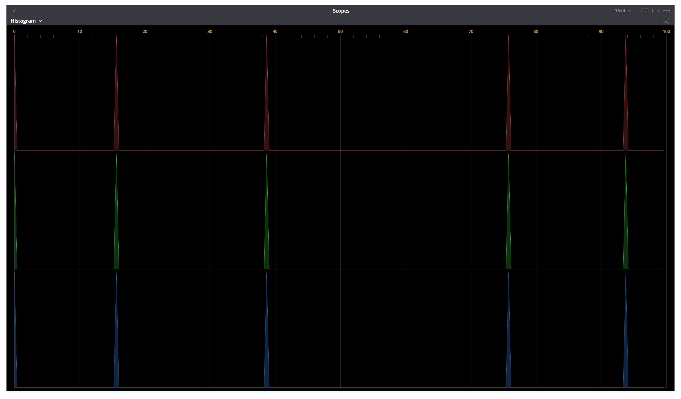
      - ACES Image (b) Histogram
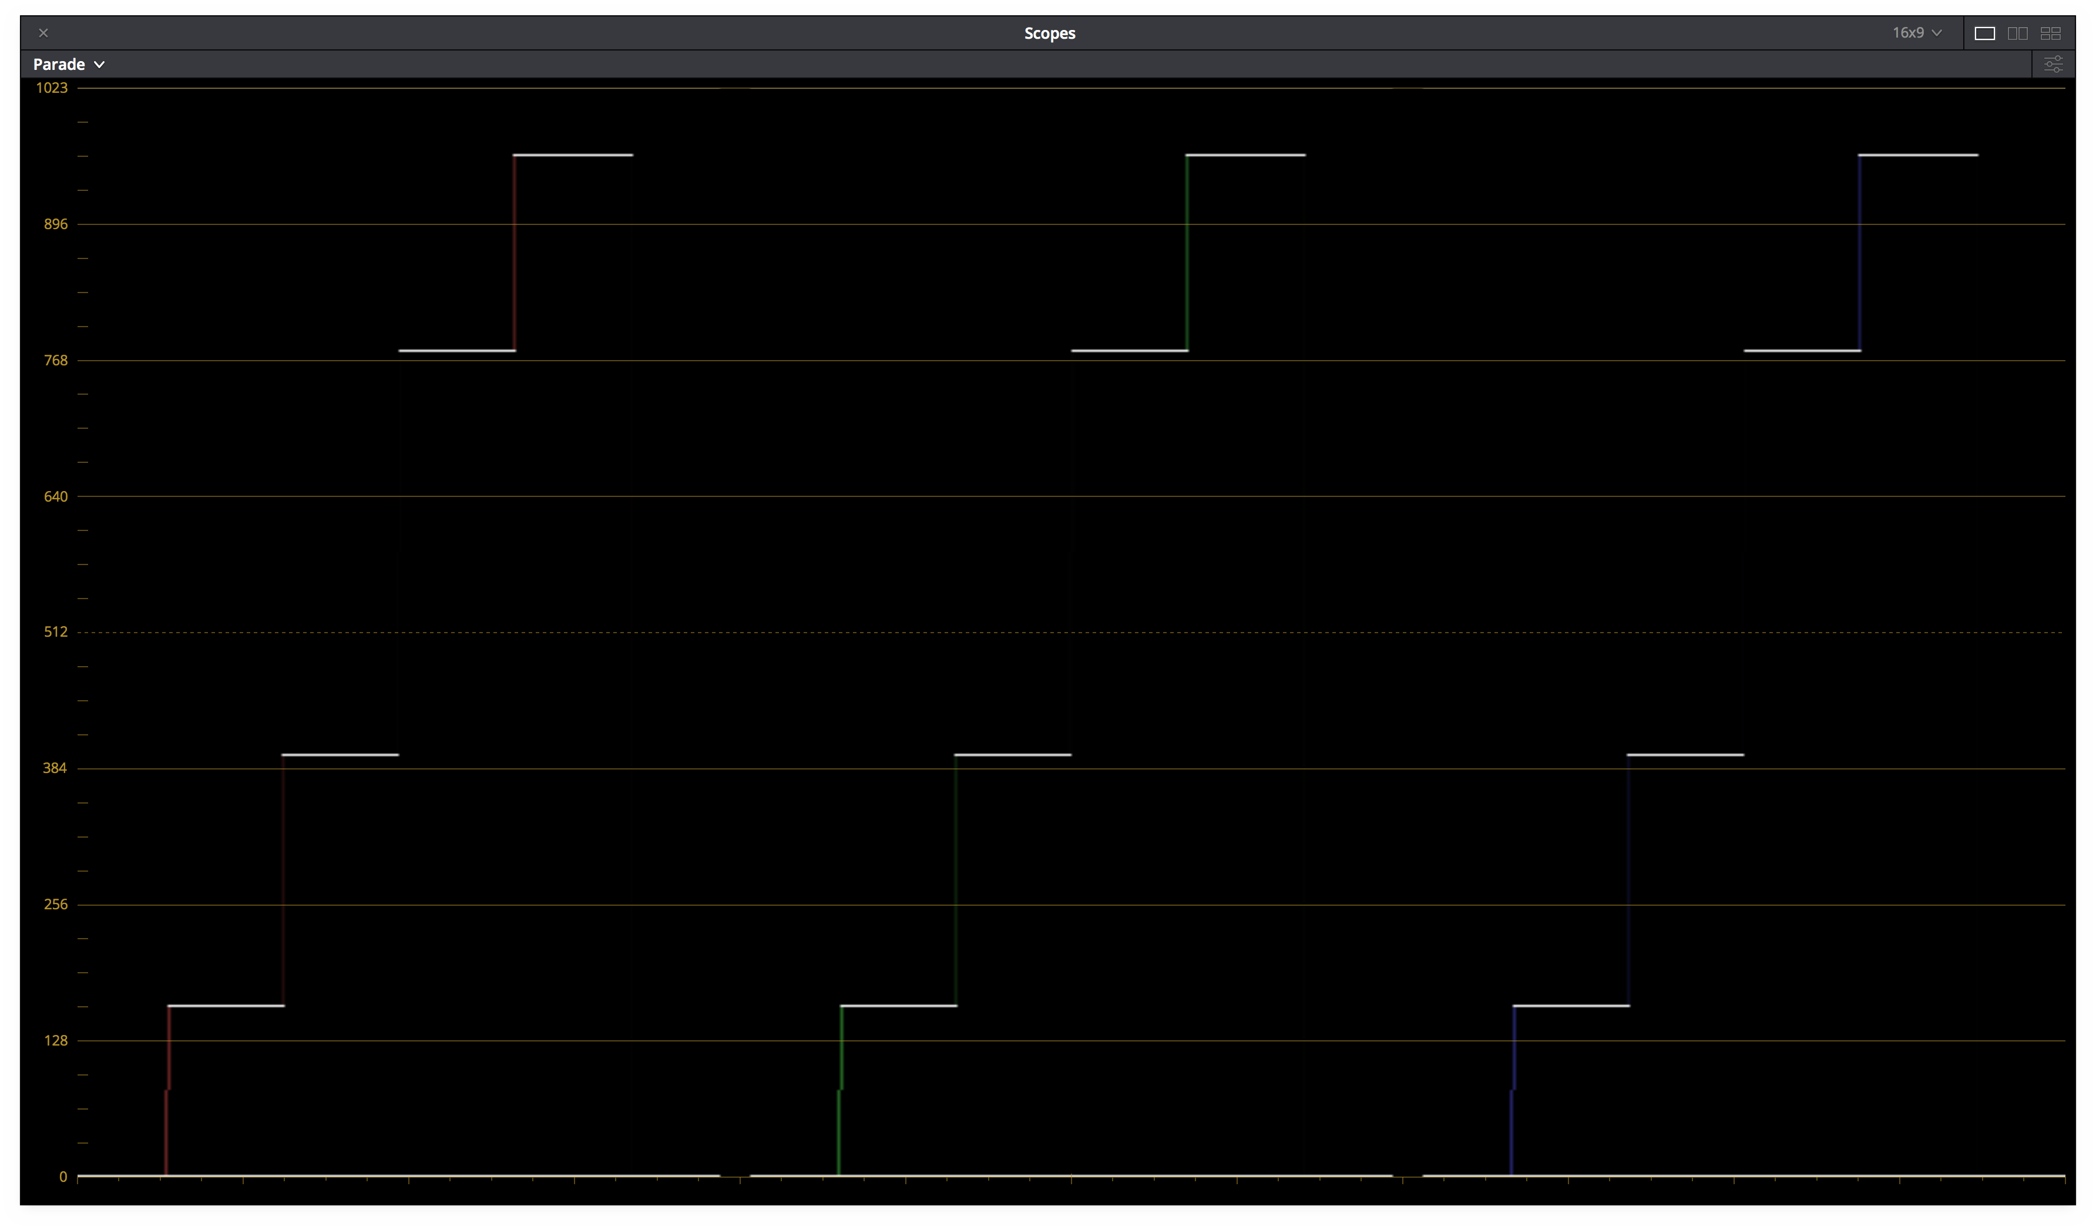
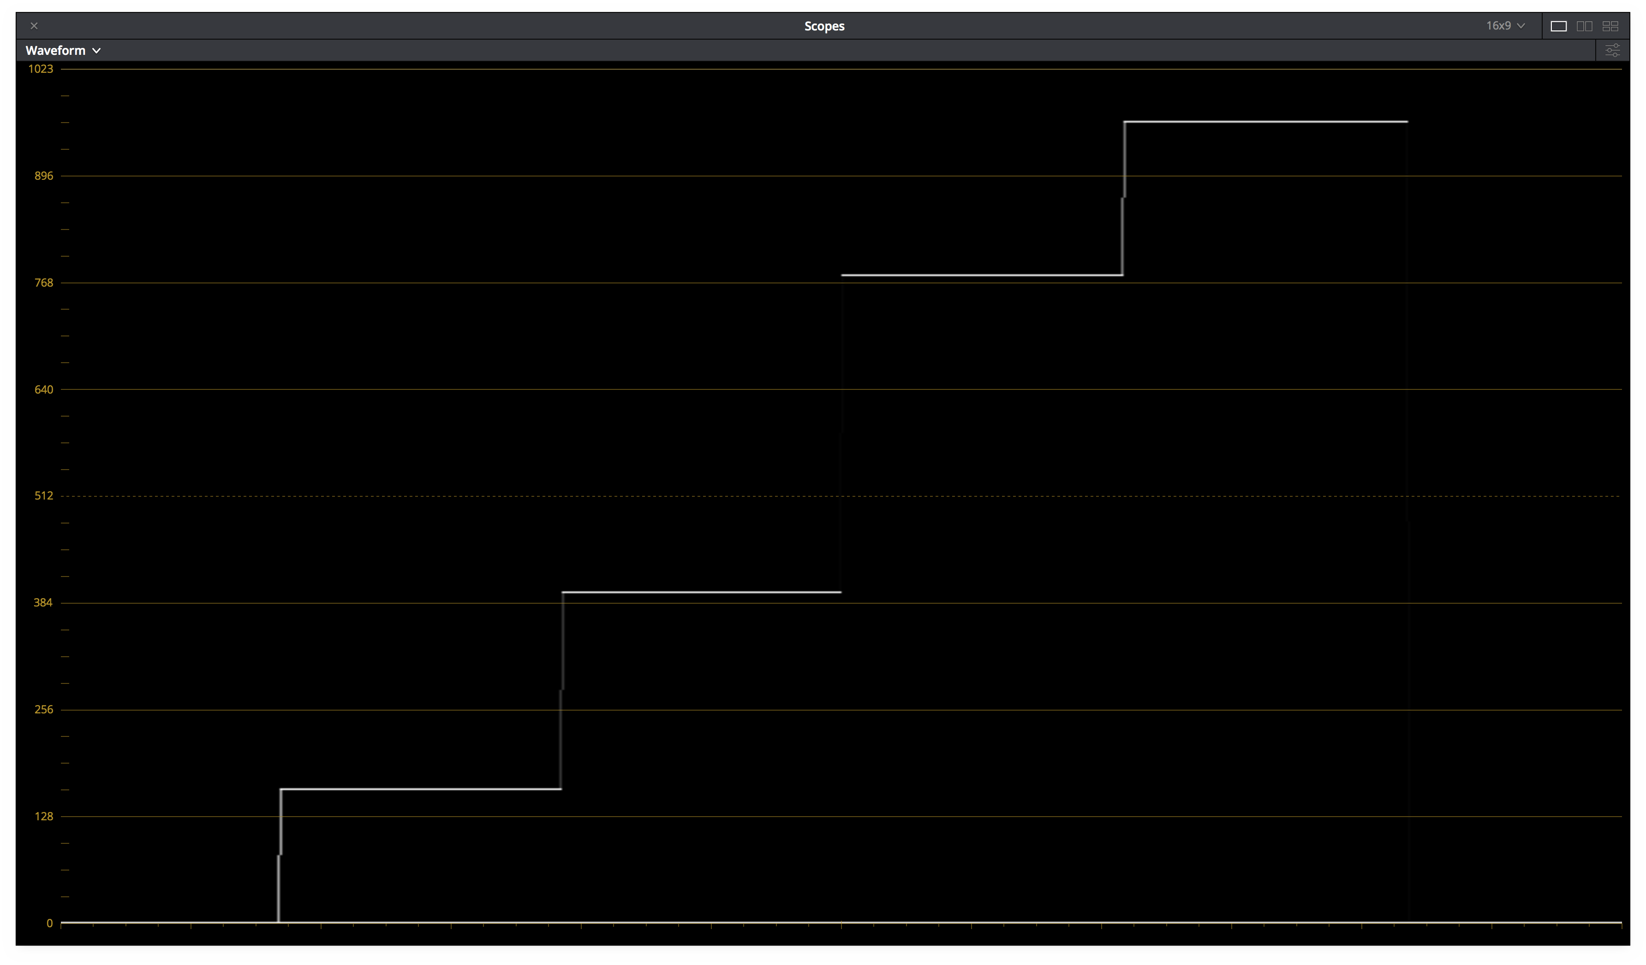
(c) Parade (d) Waveform

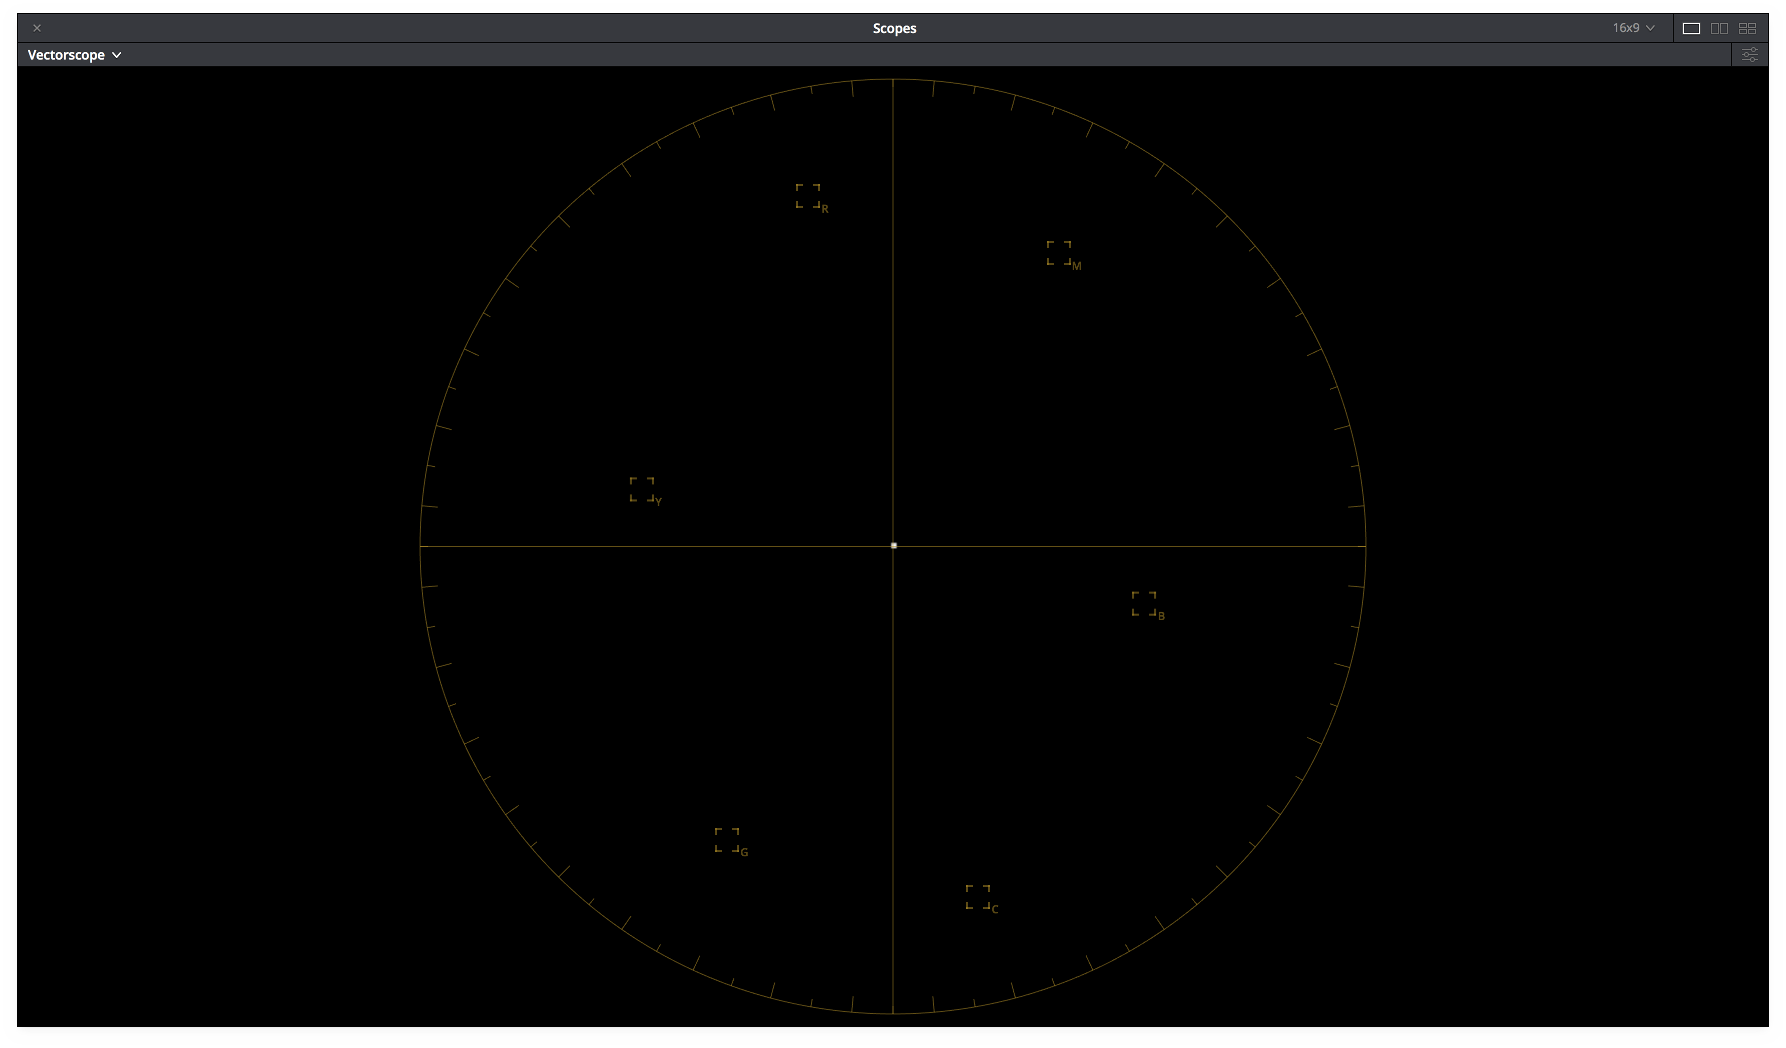
        - vectorscope
        - Projector code values as displayed on a D65 cali- brated computer monitor

Figure 4 – ODT.Academy.Rec709 100nits dim.a1.0.3 Scope Screenshots

Test Values
Table 13 contains test values can be used to confirm the proper monitor setup and ODT combination. Each of the 9 ACES RGB input values should yield the RGB noted display RGB code values (normalized 0-1, full range) when processed through the ODT.Academy.Rec709 100nits dim.a1.0.3. When driving a properly setup display with the noted display RGB code values, the light from the display should measure with the noted CIE xyY colorimetry.
If the display RGB code values do not match those in the table when using the corresponding input ACES RGB code values, it is likely the wrong ODT is being used. If the proper display RGB code values are being produced by the ODT, but he measured display colorimetry doesn’t match the display xyY code values noted, it is likely the display setup is incorrect.

Patch | ACES RGB |  |  | Display RGB |  |  | Display xyY
N1 | 1.8233 | 1.8233 | 1.8233 | 0.9000 | 0.9000 | 0.9000 | 0.3127 | 0.3290 | 77.6573
N2 | 0.2753 | 0.2753 | 0.2753 | 0.5000 | 0.5000 | 0.5000 | 0.3127 | 0.3290 | 18.9465
N3 | 0.0898 | 0.0898 | 0.0898 | 0.2500 | 0.2500 | 0.2500 | 0.3127 | 0.3290 | 3.5897
R | 0.4689 | 0.1193 | 0.0417 | 0.8275 | 0.1525 | 0.1498 | 0.6155 | 0.3303 | 14.3569
G | 0.3390 | 0.8068 | 0.0936 | 0.1500 | 0.8300 | 0.1500 | 0.3005 | 0.5889 | 46.0295
B | 0.2162 | 0.1330 | 0.8711 | 0.1500 | 0.1500 | 0.8300 | 0.1566 | 0.0709 | 5.5935
C | 0.5187 | 0.9138 | 1.0432 | 0.1500 | 0.8300 | 0.8300 | 0.2265 | 0.3287 | 50.5696
M | 0.5800 | 0.2096 | 0.9086 | 0.8300 | 0.1500 | 0.8300 | 0.3207 | 0.1589 | 18.9661
Y | 0.8237 | 0.9378 | 0.0855 | 0.8300 | 0.8300 | 0.1500 | 0.4164 | 0.5005 | 59.4021

Table 13 – ODT.Academy.Rec709 100nits dim.a1.0.3 Test Values

Broadcast Television On-Set Preview (Rec.709 SDR Refer- ence Monitor)

Summary
It has become common to preview of episodic television production on-set using a standard dynamic range (SDR) Rec.709 Reference Monitor. The display is typically configured such that equal red, green, and blue display code values will produce the chromaticity CIE x=0.3127 y=0.3290 (aka D65) on the screen. With the display configured in this manner, where the intention is to master content for broadcast, it is recommended that the ACES 1.0 ODT with the transformID ODT.Academy.Rec709 100nits dim.a1.0.3 be used.

Display Setup

Parameter | Setting
Max Luminance | 100 nits
Display White Point | D65
Primaries | Rec.709
EOTF | BT.1886
Viewing Environment | dim
Signal | RGB 4:4:4 (Full range or Legal Range)
Bit Depth | 10 or 12-bit
Table 14 – Rec.709 Display Setup

Best ODT for application

Simple Name | TransformID
ACES 1.0 Output - Rec.709 | ODT.Academy.Rec709 100nits dim.a1.0.3
Table 15 – Broadcast Television Mastering ODT

Notes
ODT.Academy.Rec709 100nits dim.a1.0.3 is intended to be used with a broadcast display that configured such that equal red, green, and blue display code values produce a chromaticity CIE x=0.3127 y=0.3290 (aka D65) on the screen and the content is intended to be viewed in a typical home viewing en- vironment. The output transform is configured such that neutral ACES source file values (ACES R=G=B) will produce equal projector code values. In this application, the image resulting on the display will mimick the content as it will appear in broadcast television mastering. Care should be taken to configure choose the proper output range as the ODT supports both full and legal range.
It’s important to note that the image on display screen should be similar in color balance to content produced with other video workflows. The color corrector scopes should reflect this white balance similarity by pro- ducing equal red, green and blue display code values for neutral ACES source file values. The scopes may however appear different in range to some video workflows. In ACES based workflows dynamic range of the source content is maintained by manipulating the content prior to the output transforms. The shape of the output transform tone scale may be reflected in the display code values being monitored on the color corrector scopes. This is common with other video workflows where a look-up table (LUT) is used.

      - ACES Image (b) Histogram
(c) Parade (d) Waveform

        - vectorscope
        - Projector code values as displayed on a D65 cali- brated computer monitor

Figure 5 – ODT.Academy.Rec709 100nits dim.a1.0.3 Scope Screenshots

Test Values
Table 16 contains test values can be used to confirm the proper monitor setup and ODT combination. Each of the 9 ACES RGB input values should yield the RGB noted display RGB code values (normalized 0-1, full range) when processed through the ODT.Academy.Rec709 100nits dim.a1.0.3. When driving a properly setup display with the noted display RGB code values, the light from the display should measure with the noted CIE xyY colorimetry.
If the display RGB code values do not match those in the table when using the corresponding input ACES RGB code values, it is likely the wrong ODT is being used. If the proper display RGB code values are being produced by the ODT, but he measured display colorimetry doesn’t match the display xyY code values noted, it is likely the display setup is incorrect.

Patch | ACES RGB |  |  | Display RGB |  |  | Display xyY
N1 | 1.8233 | 1.8233 | 1.8233 | 0.9000 | 0.9000 | 0.9000 | 0.3127 | 0.3290 | 77.6573
N2 | 0.2753 | 0.2753 | 0.2753 | 0.5000 | 0.5000 | 0.5000 | 0.3127 | 0.3290 | 18.9465
N3 | 0.0898 | 0.0898 | 0.0898 | 0.2500 | 0.2500 | 0.2500 | 0.3127 | 0.3290 | 3.5897
R | 0.4689 | 0.1193 | 0.0417 | 0.8275 | 0.1525 | 0.1498 | 0.6155 | 0.3303 | 14.3569
G | 0.3390 | 0.8068 | 0.0936 | 0.1500 | 0.8300 | 0.1500 | 0.3005 | 0.5889 | 46.0295
B | 0.2162 | 0.1330 | 0.8711 | 0.1500 | 0.1500 | 0.8300 | 0.1566 | 0.0709 | 5.5935
C | 0.5187 | 0.9138 | 1.0432 | 0.1500 | 0.8300 | 0.8300 | 0.2265 | 0.3287 | 50.5696
M | 0.5800 | 0.2096 | 0.9086 | 0.8300 | 0.1500 | 0.8300 | 0.3207 | 0.1589 | 18.9661
Y | 0.8237 | 0.9378 | 0.0855 | 0.8300 | 0.8300 | 0.1500 | 0.4164 | 0.5005 | 59.4021

Table 16 – ODT.Academy.Rec709 100nits dim.a1.0.3 Test Values

Broadcast Television On-Set Preview (iPad)

Summary
Summarize the application in real world terms

Best ODT for application

Notes

Test Values

High Dynamic Range On-Set Preview (Rec.2020 HDR Refer- ence Monitor)

Summary
Summarize the application in real world terms

Best ODT for application

Notes

Test Values

Computer Visual Effects (VFX) Generation (Desktop Com- puter Monitor)

Summary
Summarize the application in real world terms

Best ODT for application

Notes

Test Values

HDR10 Deliverable Generation (HDR 1000 nit Rec.2020 ST- 2084)

Summary
Summarize the application in real world terms

Best ODT for application

Notes

Test Values

Dolby Vision Master (4000 nit Dolby Pulsar PQ Master)

Summary
Summarize the application in real world terms

Best ODT for application

Notes

Test Values

- Recommended Workflows
This section is intended to outline the recommended usage of ACES Output Transforms as they apply to common workflows applicable to feature motion picture and episodic television production.

Feature Film – On-Set to Digital Intermediate

Summary
It is common in the production of digital feature films to monitor the output of the camera on-set to check for framing, exposure, and often to create looks. Looks are often created on-set or near-set using an on-set grading system with the result being a series of ASC-CDL values that are passed to digital intermediate (DI) mastering facility as a starting point for final grading. In order to insure looks are set and communicated from on-set to the DI master facility as intended, it’s important that the correct Output Transforms be used in each location. The following is a recommendation for the usage of Output transforms for a common on-set to digital intermediate workflow.

Workflow
The complete workflow from camera to post is beyond the scope of this document, but Figure 6 shows a typical workflow for the creation and communication of looks during feature film production.

Figure 6 – Feature Film On-Set to DI Workflow

In this on-set to digital intermediate workflow a Rec.709 reference display is connected to the on-set grading system and a digital cinema projector is connected to the DI grading system. In this workflow it is suggested that the on-set grading system be configured according to the Output Transform Application specified in Section 2.3. The DI grading system should be configured according to the Output Transform Application specified in Section 2.2, or alternatively Section 2.1. The recommendations are summarized in Table 17.

System | Display | Suggested ODT
On-set Grading | Rec.709 Reference Monitor | ODT.Academy.Rec709 D60sim 100nits dim.a1.0.3
DI  Grading | P3 Digital Cinema Projector | ODT.Academy.P3D60 48nits.a1.0.3  or  ODT.Academy.P3DCI 48nits.a1.0.3

Table 17 – Summary of suggested ODTs

Discussion
In the On-Set to Digital Intermediate workflow, using the suggested ODT will provide a white point match between the two environments. The displays will not match to the degree there are colors in the content that would take advantage of the P3 color space in DI since those colors could not be reproduced on-set with the Rec.709 monitor. It’s important to recognize that the colorimetry will not measure as matching due the

the surround environment differences associated with the DI grading and On-set ODTs. The On-set ODT is designed for a dim surround environment where the DI grading ODT is designed for a dark surround environment. If viewed in their correct respective environments using the suggested ODTs should provide a visual match since the ODTs compensate for perceptual differences imposed by the viewing environments.

